AI Health-Bot: Predictive Symptom Analysis and Voice-Based Treatment Recommendations

# OBJECTIVE :

1. **The AI Enhance Predictive Symptom Analysis : Develop advanced machine learning algorithms capable of accurately analyzing user-reported symptoms for early detection and prediction of potential health issues.**
2. **Optimize Voice-Based Interaction System : Integrate state-of-the-art automatic speech recognition (ASR) and natural language processing (NLP) technologies to create a robust voice-based interaction system.**
3. **Personalize Treatment Recommendations: Develop algorithms for creating comprehensive user profiles by considering historical health data, preferences, and responses to previous treatments.**
4. **Implement Robust Privacy and Security Measures : Utilize encryption algorithms to secure user data during transmission and storage, ensuring confidentiality and compliance with healthcare data regulations.**

**BLOCK DIAGRAM OF PROPOSED WORK :-**

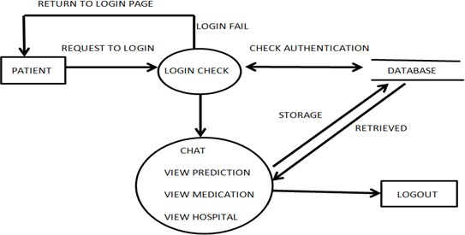

User

Data Storage

Exit

***system flow architecture for AI Health-Bot***

**METHODOLOGY :-**

1. Requirement Gathering and Analysis : The first step of this project is identify the key requirements of the Health-Bot , including symptom analysis, disease prediction, treatment recommendation, voice input system, GUI design, and data storage. Firstly we conduct the research to understand user needs, existing medical chatbots, and relevant technologies.
2. System Design : The next step is to design the overall architecture of the Health-Bot system, considering the integration of NLP algorithms, model training, voice input system, GUI frontend, and database management. Then we define the functionalities and interactions of each component within the system.
3. Development Environment Setup : We create or set up the development environment with appropriate tools and frameworks for programming, NLP processing, voice recognition, and web development. Here we install and configure necessary libraries and dependencies for Python programming and NLP algorithms.
4. Implementing NLP Algorithms : The important task is develop NLP algorithms to analyze user-input symptoms, extract relevant information, and predict potential diseases. Here we train machine learning models on medical data to enhance the accuracy of disease prediction.
5. Implementing Deep Learning Algorithms : The important task is develop Deep Learning algorithms in that use neural networks for process the data and predict potential diseases on the basis of user symptoms.
6. Voice Input System Integration : Then we integrate a voice input system into the Health-Bot , allowing users to input symptoms and queries using voice commands. Here we implement speech-to-text conversion to convert spoken input into text format for further processing.
7. GUI Frontend Development : Design and develop a GUI frontend for the Health-Bot , resembling a website interface.We create user-friendly interfaces for symptom input, disease prediction results, treatment recommendations, and browsing past consultations.

**FLOWCHART : -**

**Prof. Priyanka Vyas , PCET’s Nutan College of Engineering and Research Talegaon, Pune.**

**Rohit Gaware & Tanuj Choudhary**

User Inputs Symptoms/ Voice Input System

Symptom Analysis using NLP Algorithms

Retrieve Treatment and Medications

Display Treatment Recommendations

Store History

Start

End

Predict Disease

**System Flow Diagram of the AI Health-Bot**

**RESULTS : -**

1. **Successfully developed an RNN model with a low loss of 0.2, ensuring high accuracy in understanding and processing user inputs.**
2. **Integrated the RNN model with an aesthetically pleasing graphical user interface (GUI), enhancing user experience and accessibility.**
3. **Implemented robust voice input and output systems, allowing for intuitive and natural user interaction.**
4. **Developed a secure system for storing user data, ensuring privacy and data protection.**
5. **Implemented a strong login and security framework to safeguard user information and provide a secure environment.**

**OUTPUT IMAGES :-**

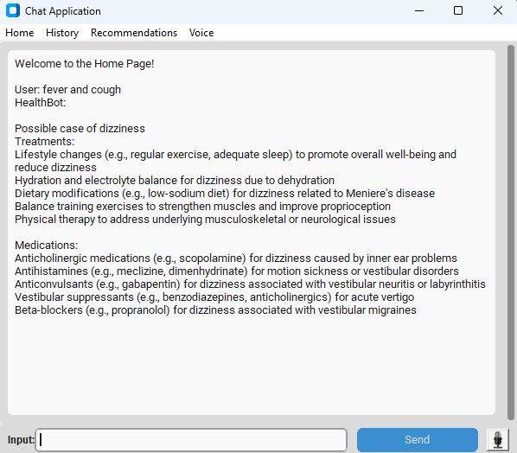

Disease Prediction and Treatment & Medications Recommendations

# CONCLUSION :-

# In the conclusion the AI Health-Bot project demonstrates the potential of Artificial intelligence and chatbot technology to revolutionize healthcare delivery. By providing timely, accurate and personalized medical assistance, the health-bot Aims to improve patient outcomes, enhance accessibility to healthcare service. As technology continuous to evolve the AI Health-bot will remain at innovation